**UI/UX Requirements and Screen-by-Screen Details**

**1. User Authentication Screens**

**A. Login Screen**

* **Purpose:** Allow employees/ admin to log in securely.
* **Fields:**
  + Username (text input)
  + Password (password input)
* **Actions:**
  + Login button (submits credentials to /token)
* **Feedback:**
  + Show error for incorrect credentials

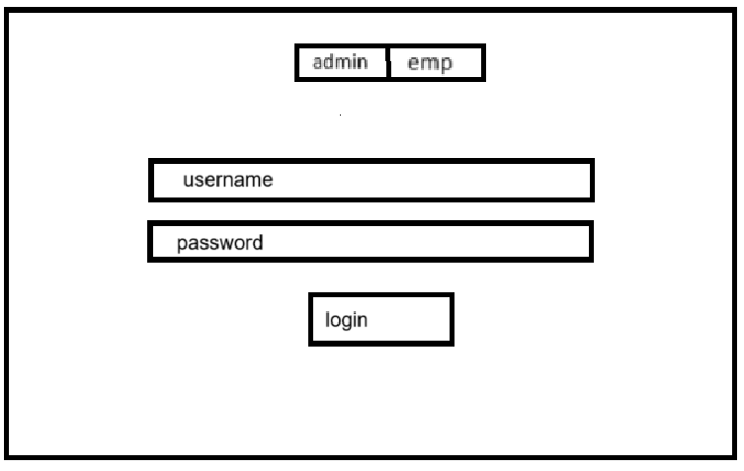

**2. Dashboard / Home Screen**

* **Purpose:** Provide access to all major features after login.
* **Elements:**
  + Navigation to:
    - Employee Profile
    - Attendance (Login/Logout)
    - Leave Management
    - Logout button

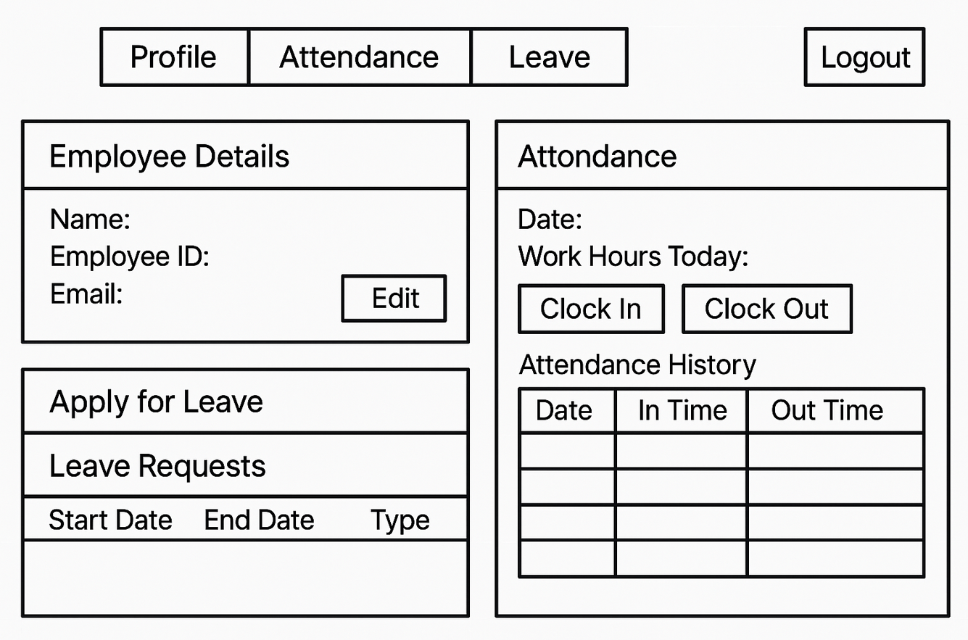

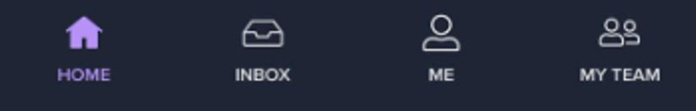 (Home page navigation)

**3. Attendance Screens**

**A. Attendance Log Screen**

* **Purpose:** Show attendance records for the user.
* **Elements:**
  + Table/list with:
    - Date
    - Login time
    - Logout time
    - Work hours (auto-calculated)
    - Leave status
  + Option to filter by date range

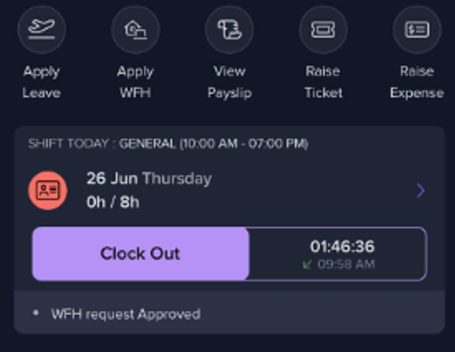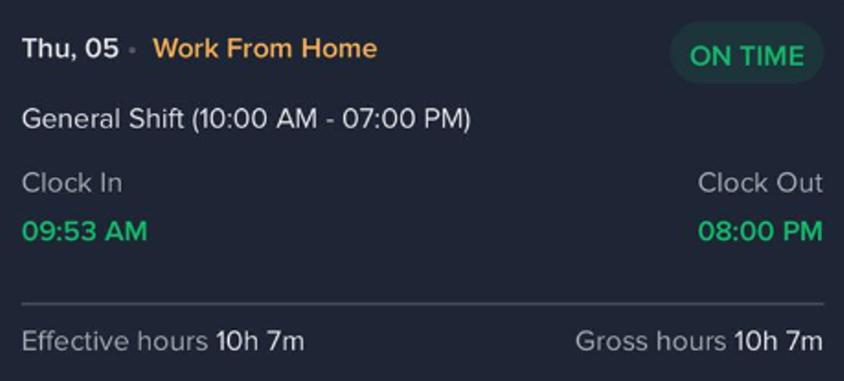

**B. Login/Logout at Work Screen**

* **Purpose:** Mark the start / end of the workday.
* **Fields:**
  + "Login" button (records current timestamp as login_time)
  + "Logout" button (records current timestamp as logout_time)